

gelFAST Anywear FAQ
(Frequently Asked Questions)
Clinician’s Informational Guide

MX Revision code 2.03

Contents:
Frequently Asked Questions:
Section 1: Caregiver Use Related
Section 2: Patient Care Related
Section 3: General Comments

Section 1:
Caregiver-related questions

Q: What is this? Why do we need this? What’s the point of this product?

A: gelFAST is a wearable alcohol gel dispenser. It has been clinically shown to significantly increase hand hygiene rates among caregivers. gelFAST will enable you to provide the best care to your patient by helping keep your hands free of potentially harmful infectious microorganisms.
Q: Why is cleansing hands more often so important?

A: Better hand hygiene is the easiest way to significantly reduce hospital-acquired infection rates. Your patients depend on you for the best possible care, and keeping hands clean is a basic first step.

Q: Could this leak on me?

A: Not if used properly. gelFAST was designed specifically to prevent accidental dispensing, and under typical operating conditions should provide trouble-free and spill-free use.
People have run marathons wearing gelFAST (seriously!), and have not reported any leaks or spills.

It is important to dispense the gel properly for unit to function correctly. FINGERS SHOULD SQUEEZE THE WAVES OF THE CARTRIDGE to dispense gel.
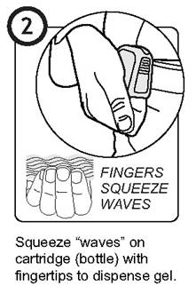

Q: How long will a cartridge last?

A: If you are cleansing at the recommended rate…

ONE CARTRIDGE = about 8 hours.

One cartridge will last approximately 30-40 hand cleansings, or roughly one typical 8 hour work shift.
If you find that you are going through far less than that, it is time to increase the number of times you perform hand hygiene.

Q: Where do I get cartridges?

A: gelFAST Cartridges are available from the CLINICAL MANAGER: ENTER STOCK LOCATION

Q: What do I do with my empty cartridges?

A: Empty cartridges may be thrown into typical plastic bottle recycling, if your facility has recycling capabilities. Spent cartridges are not considered HazMat, and are specially designed for easy recycling.

Q: When should I wear my gelFAST?

A: For best results, wear gelFAST as you are beginning your shift. It is often easiest to start the day off with a fresh cartridge, to ensure an uninterrupted workflow. Having an extra cartridge in your pocket will save you a trip to supplies, and keep your workflow uninterrupted.
Q: I left my unit at home. What should I do?

A: Get another one from ESA. Just remember to bring yours back from home your next shift.

Q: How do I change the cartridge?

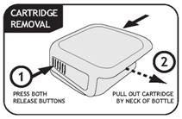

Q: How do I insert a new cartridge?

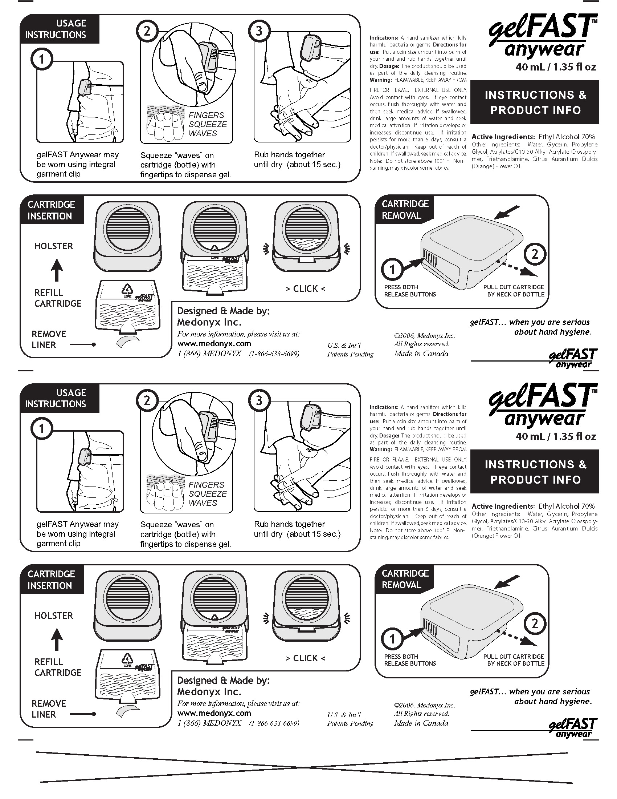

Q: BUT: Won’t alcohol gel dry out my hands? It has before…
A: Alcohol dries out hands far less than soap and water, so this comment speaks of increased hand hygiene. With that said, gelFAST contains three separate skin conditioners to keep hands in great shape for the comprehensive hand hygiene needed for best patient care practices.

While different skin types can react differently to various formulations, this one has been developed to keep hands in great shape. We know that you must like the gel in order to keep using it!
Nonetheless, different people may have different reactions. In the event that you still experience skin dryness, you can apply a moisturizing lotion once at the beginning of a shift and once towards the middle (for instance, lunch breaks) for the most demanding skin types.

Q: Can I use moisturizing lotion with this product?

A: Yes, just ensure that the lotion is applied with enough time to be fully absorbed in the skin before using the alcohol gel for cleansing purposes.

Q: Will long-term use damage hands?

A: Typically, skin becomes better- conditioned over time, because of the multiple moisturizers used in gelFAST.

Q: What if I find the units uncomfortable?

A: Try wearing it a different way – gelFAST can handle many different types of wearing applications. Find the way that works best for you. gelFAST Anywear is flexible: it was developed to be worn… anywhere. It can be worn:
- using the built-in garment clip
- on a lanyard
- on a shirt pocket, etc.

In fact, you may think of ways to use gelFAST that we didn’t even anticipate! If at first gelFAST feels a little awkward and unusual, bear with it: it sometimes can take a few days to fully get comfortable with any new thing, gelFAST included.

Q: What if I don’t have a belt or a pocket to clip the units onto?

A: gelFAST doesn’t require a belt for the garment clip to work – it was designed to be clipped onto scrubs, skirts, or almost any garment. If clipping is not your thing, gelFAST is flexible, too: you can wear it on a lanyard (necklace), or on a retractable ID cord reel. As long as it is always accessible for instant hand hygiene, not stowed in a pocket or purse, it is being used properly.

Q: What if it falls off? The clip doesn’t seem very tight…

A: Some users have reported that on very thin fabrics, they sometimes dislodge their gelFAST and they fall off. To prevent this, Medonyx (the gelFAST people) provides a small tab of sticky-backed foam can be stuck to the back of a unit, called a “Thin Fabric Adapter.”

Q: I don’t have room left on my uniform with all other gadgets (e.g., pager, Blackberry) already there.

A: gelFAST can significantly improve your hand hygiene rates, the best and easiest way to reduce nosocomial infections. Pagers and Blackberry units don’t. It is a priority to keep hands clean, and gelFAST is the easiest way to do that in a sustained and consistent way.

Q: Won’t spilled alcohol damage clothing/shoes?

A: Alcohol gel typically washes out of clothing easily. While some different fabrics react differently to alcohol, the gel is generally clothing safe.

Q: Is the gel toxic or safe? What happens if it is ingested? What happens if my gel-covered hands touch food I’m eating?

A: The gel is food-grade and non-toxic. The formulation was developed not only for healthcare workers but also for food preparation personnel. While the gel tastes really bad – (it has been “denatured” - or made to taste very bitter), it is generally safe if accidentally ingested. If gel-covered hands touch food that is being eaten, there may be a bitter taste, so it is recommended to wash hands with soap and water before eating – a good practice in any event.

Q: Can units accidentally squirt patients or other caregivers?

A: gelFAST is designed to apply gel only into the palm of your hand. It is not foreseeable that a patient or co-worker could be squirted accidentally.

Q: How do we know what is the correct amount to dispense?

A: Following Health Canada and Center for Disease Control (CDC) guidelines, apply enough gel to fully cover hands during a rinse operation for 10-15 seconds. The rough guideline is to apply about 1-2 ml depending on hand size, or about the size of a quarter.

Q: Is space for fingers too small?

A: While it may visually appear that finger space is small, especially when the unit is looked at when not worn, there is enough space for even large fingers. It has been tested with very tall and large-fingered people, who reported that there was ample space. If you have a different reaction, use fewer fingers to dispense.
Q: I’ve had my cartridge fall out. Why was that?

A: Most likely, the cartridge wasn’t fully inserted. There are two retention “ears”, one on each side of the unit. These should both be engaged (they will appear flush to the side of the unit). If the cartridge was inserted at an angle, these ears may not have both engaged. Try inserting the cartridge fully, ensuring that both the “ears” are fully engaged.
Make sure that that the cartridge wasn’t inserted backwards either.

Section 2:
Patient care-related objections / questions:

Q: Do germs develop resistance to alcohol?

A: No. While antibiotics and other drugs finely target the intricate working mechanisms of pathogens, alcohol is a solvent that actually dissolves the cell walls of microorganisms. While there are a select few microorganisms that have long been resistant to alcohol (e.g. Sporoform C. Diff.), leading health authorities assert that alcohol is and continues to be the most effective method of rapidly disinfecting the hands.

Q: Does gelFAST pose a cross-infection risk?

A: No - gelFAST significantly lowers the risk. Leading clinical experts* agree that gelFAST does not pose a cross-infection risk, nor do bottles become infected. The primary vector in nosocomial infections are caregivers’ hands, not clothing or accessories. gelFAST significantly increases the hand hygiene frequency of caregivers, lowering the risk to patients. And, unlike wall-mounted pumps, gelFAST is used by only one person - you.

* Dr. Allison McGeer, Mt. Sinai Hospital, Toronto, Ontario, Canada.
* Dr. Shmuel Shoham, Washington Medical Center, Washington D.C., USA.

Q: I wear gloves already. Why would this help?

A: Because gloves may protect the caregiver, but often they don’t protect the patient as well as disinfected hands; gloves are often not changed properly between patients, leading to a significant risk of cross-infection. Thorough hand disinfection is to be performed between each glove change, and gelFAST makes this very fast and easy.

Q: Are already-opened units safe to use?

A: gelFAST units that have already been opened are still safe to use. Please note that there is sufficient gel to allow for a work shift with no stoppages. We recommend keeping a spare cartridge in a pocket to avoid unnecessary trips to the supply area and to maintain a constant workflow.

Q: Is alcohol gel really that effective against germs?

A: Very. Multi-year clinical trials conducted world-wide by authorities such as the World Health Organization, the Centers for Disease Control, Health Canada, and others have shown that alcohol is significantly more effective than soap and water in combating infection because alcohol is the most reliable means of properly disinfecting hands – even more so than soap and water. And gelFAST’s high (70%) ethyl alcohol content ensures efficacy against the majority of common infectious microorganisms.

Section 3:
General Comments

Q: Is gelFAST eco-friendly?

A: Yes, A few key facts:

- An empty cartridge weighs only 8 grams, or about ¼ of what a small empty Evian water bottle weighs.

- The gelFAST cartridge plastic is LDPE (low-density polyethylene), one of the most recyclable – and recycled – materials available.

- The alcohol gel of gelFAST is made of 100% renewable, bio-based corn product (yes, corn.) Often, alcohol can be made from many materials, even petroleum distillates. gelFAST’s active ingredient – ethyl alcohol – is from a 100% natural and renewable source.
Q: I’d really like to tell you about my experience with gelFAST. How do I do that?

A: Excellent – we love to hear your feedback. You can contact us directly at any time:

Customer Service
Medonyx Inc.
Toll Free : (866) MEDONYX
Local : (416) 633-6990
Email : info@medonyx.com

